CSE598 : Computer graphics

Submitted by : Rajat Aggarwal, Masters student

**Instructions – Assingment 4,**

*references written with source code.

Output :

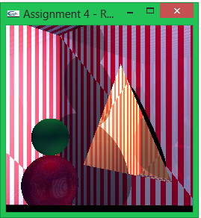

Note : this figure is taken without back wall (details later about this)

Lets start with navigation : Use w,a,s,d for movement and rotation in horizontal 2D plane. There is also option to use q and z for up/down head movement (it works, but is not the best)

1. Start by moving around normal scene to where you want your camera to be positioned. Right click and press on ray tracing to start ray tracing (BUT wait, don’t forget to put on light!!!). Press 1 for light over head of snowman and 2 for light on lower corners of the wall behind you.
2. Once you are done, you just have to wait for everything to render. A snowman with three sphere will be drawn, shadows will be cast, 2 mirrors will be drawn, showing the pattern of wall on opposite wall.

Question wise details of implementation

1. Procedural texture : Walls are stripped and floor is checkerboard. Walls are not exactly stripped as they should be, the two triangles are not coinciding their pattern, but it is easy to fix. Leaving it like that for time constraints, and also because it helps debugging.
2. Snowman in middle of room sitting on floor – Checked. Spheres are refelective too, notice how they are shinning and showing wall pattern
3. Two mirrors on wall – Checked. Material details were taken from material.txt in assignment 3. Mirrors are placed a little infront of walls – Notice the shadow effect behind them.
4. Perspective camera – Already setup, values are being read from xml file and every pixel is calculated in camera coordinates.
5. Camera movement – See above how to navigate. There is one flaw, angle will always start from 10 degrees, but once you are moving there should not be any problem or discontinuity.
6. Phong lighting – Lights are positioned right above snowman and at lower left corners of back wall. Press 1 for starting first and 2 for starting both the 2nd and 3rd together. Ambient light values are taken into consideration. Also notice how shadows gets softer due to light from other source.
7. Recursive reflection – Both the mirrors will be showing the opposite wall pattern blended very nicely with their own material color. If you place a colored sphere in front of the mirrors and look with correct angle, it will correctly show this sphere too. Even walls have got minute reflection to them. Recursion is done only twice, so only the reflection is being seen, no reflection of reflection.

Drawbacks :

Code got a little messy and I had to give up debugging some defects with reflection. For some reason, having back wall creates an unintended shadow. Also mirrors color gets blended with background in some places and other times with its own shadow, gives it a very weird combination. Here is a 640*480 rendering of the whole scenario: 